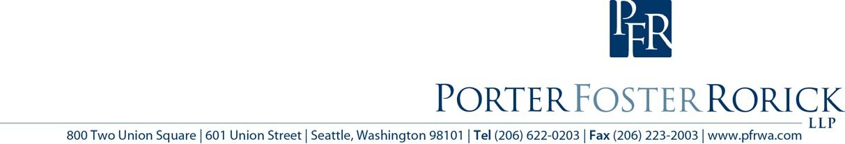

**Public Records Disclosure Training**

May 8, 9 am to 3 pm

Two Union Square Conference Center, Seattle

Join Valerie Walker and Jay Schulkin of Porter Foster Rorick for a full day of hands-on training in processing public records requests and avoiding mistakes that lead to legal liability. This workshop will satisfy the legally-mandated training for district officials and public records officers. Registration is only $150 per person and includes lunch. Reserve a space by sending an e-mail with the names of attendees t[o info@pfrwa.com.](mailto:info@pfrwa.com)